SQL Server Database Mirroring

(Example)

1. Let's take an example to apply database mirroring with one of the database named "PatientInfo", Open SQL Server Management Studio 2008 and make sure that the database is in the Full Recovery mode. To check the recovery mode, right click the database name, select Properties and then select Options, or by using the following T-SQL:
2. USE master;
3. GO
4. **ALTER** **DATABASE** PatientInfo
5. **SET** RECOVERY **FULL**;
6. GO

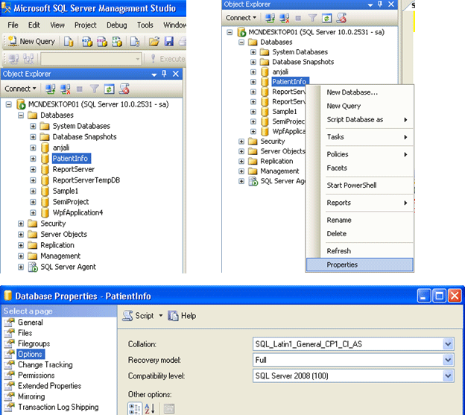

**Note:** If it is not in the FULL recovery Mode then, modify it to use the full recovery mode:

2.Once we modify the recovery model of our database to FULL, it's time to create a full Backup on the principal server instance, create a full backup of the principal database as follows:

1. BACKUP **DATABASE** PatientInfo
2. **TO** DISK = 'D:\PatientInfo.bak'
3. **WITH** FORMAT
4. GO

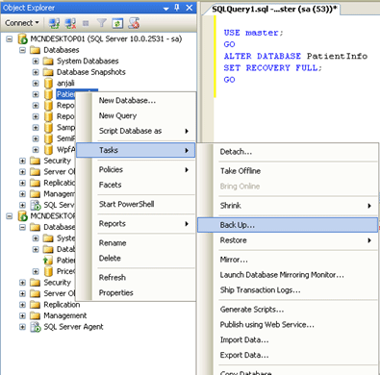

1. Now, copy the full backup to the mirror server.
2. Restore the full backup WITH NORECOVERY onto the mirror server instance. The restore command depends on whether the paths of principal and mirror databases are identical. Following T-SQL is used to do this:
3. RESTORE **DATABASE** PatientInfo
4. **FROM** DISK = 'D:\PatientInfo.bak'
5. **WITH** NORECOVERY
6. GO

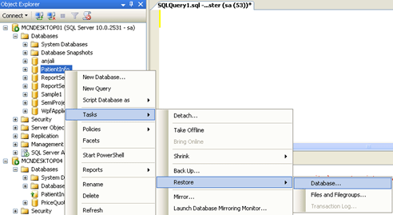

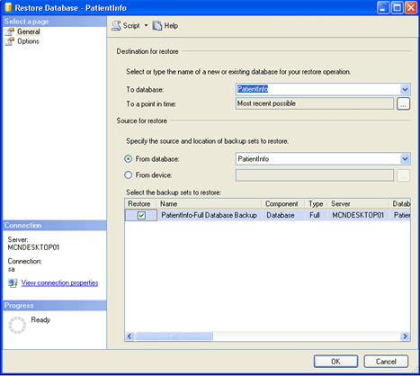

**Note:**If the path names of the principal and mirror databases differ, we cannot add a file, because on receiving the log for the add file operation, the mirror server instance attempts to place the new file in the location used by the principal database.

1. After creating a full backup, it is important to create a log backup on the principal database. The following Transact-SQL statement backs up the log to the same file used by the preceding full backup:
2. BACKUP LOG PatientInfo
3. **TO** DISK = 'D:\PatientInfo.bak'
4. GO



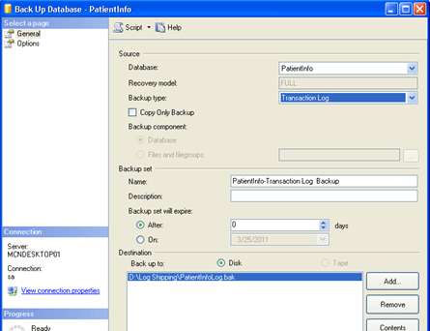

**Note:**Also the database name on the mirror must be the exact same name as the principal.

1. Before we can start mirroring, we must apply the required log backup (and any subsequent log backups). For example, the following Transact-SQL statement restores the first log from D:\PatientInfo.bak:
2. RESTORE LOG PatientInfo
3. **FROM** DISK = 'D:\PatientInfo.bak'
4. **WITH** FILE=1, NORECOVERY
5. GO
6. If any additional log backups occur before starting mirroring, we also restore all of those log backups, in sequence, to the mirror server using WITH NORECOVERY. For example, the following Transact-SQL statement restores two additional logs from D:\PatientInfo.bak:
   1. RESTORE LOG PatientInfo
   2. **FROM** DISK = 'D:\PatientInfo.bak'
   3. **WITH** FILE=2, NORECOVERY
   4. GO
   5. RESTORE LOG PatientInfo
   6. **FROM** DISK = 'D:\PatientInfo2.bak'
   7. **WITH** FILE=3, NORECOVERY
   8. GO

Let's see how to Perform Database Mirroring with screenshots

Select the **principal database**. Right click on the database name and select**Properties** and then click on "**Mirroring**" the following window will appear

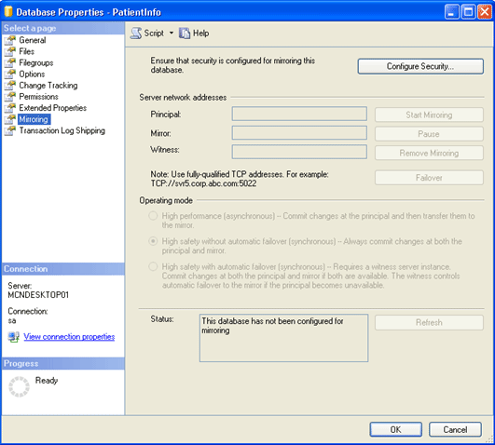

* Click on the "**Configure Security**. . ." button.

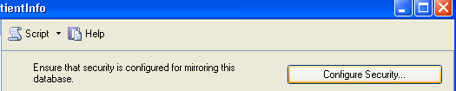

* From the following window Click **Next** to get started.

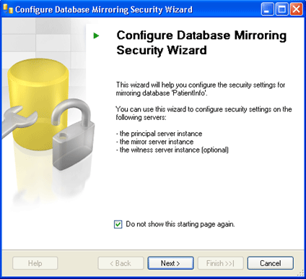

* Here we have the option that if we want to use a witness server or not, select **yes** and click **Next**.

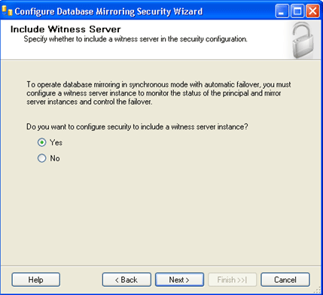

Again select if there is a need to use a witness server and Click**Next**.

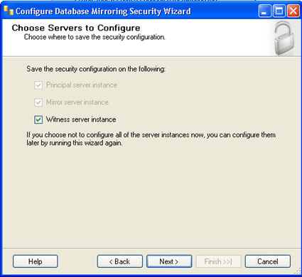

Now first of all set up the **principal Server**.

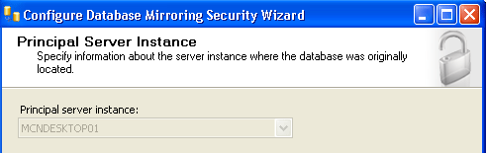

* Select the instance, click on the checkbox if we want to encrypt the data and define the listener port, which Database Mirroring will use to communicate with the other instances in the mirror. Also select the endpoint name. Click **Next**.

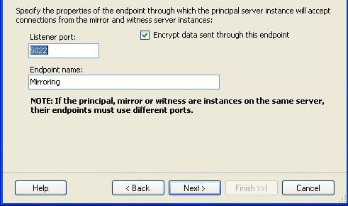

* **Note:** We can use the default number/Name or specify our own for both: Port, Endpoint.
* Secondly, set up the Mirror Server similarly as we have done for Principal Server: select the instance; select encrypt the data; define the listener port and select the endpoint name and connect to it. After connecting successfully Click **Next**.

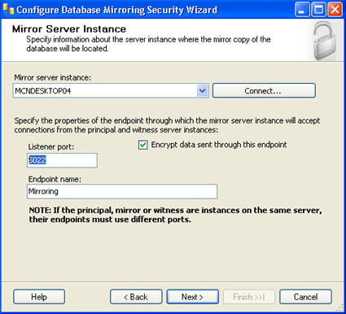

**Note:** We can use the default number/Name or specify our own for both: Port, Endpoint.

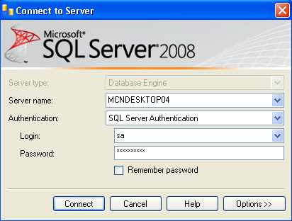

* Thirdly, it's time to set up the Witness Server as we have decided to use a witness previously. So for this also select the instance; click to encrypt the data; define the listener port and lastly select the endpoint name. Again Connect to it and Click**Next**.

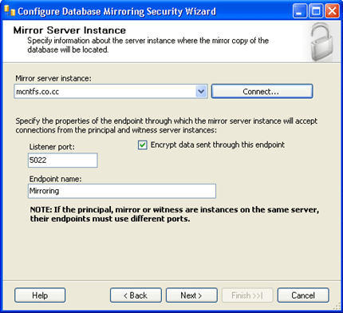

* **Note:** For witness server also we can use the default number/Name or specify our own for both: Port, Endpoint.
* Here we can set up special security credentials if we want to do (not Compulsory). Because all of the instances for this Demo are on the same server using the same accounts, they have been left blank. So directly Click **Next**.

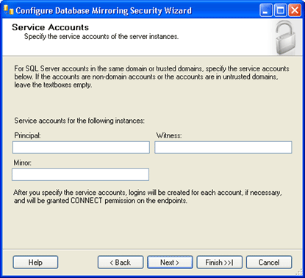

* Last but not the least Click on **"Finish".**

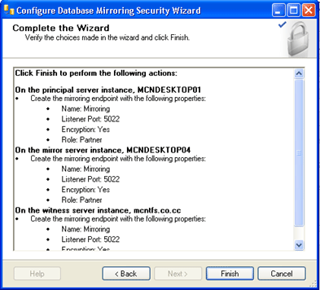

* When we click on finish the following window configure the endpoints and shows its status means that it will show whether the process was successful setup or not.

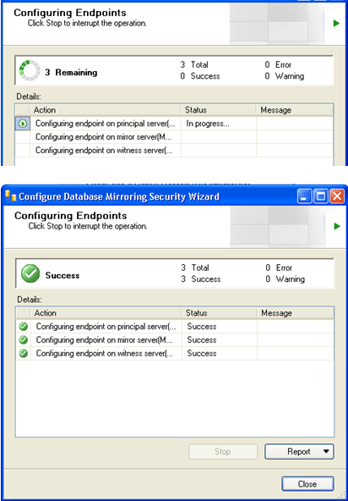

* **Note:** We can also see the reports if we want to see.
* Click on **close button** and we will the following window on our desktop. To begin mirroring select **"Start Mirroring"** and the mirroring process will begin. And if we want to make the changes than click on "Do Not Start Mirroring"

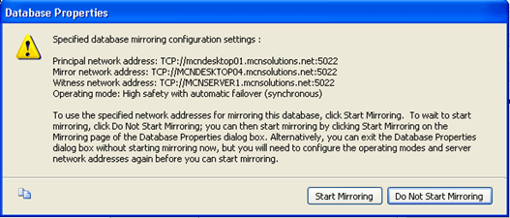

Finally, our mirroring will starts as shown below. And we can see in Status box that the data has been **synchronized between the principal and the mirror.**

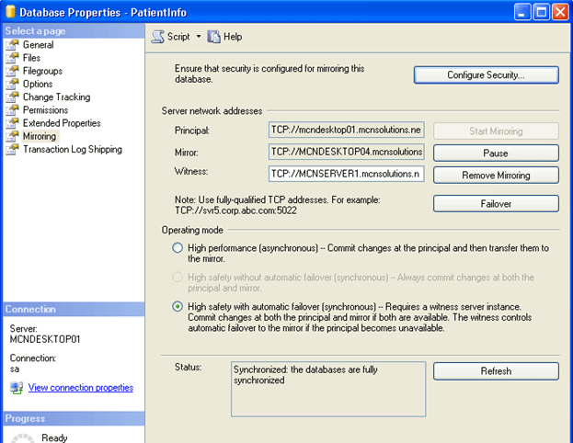

**Note:** We have some more options on this window which are as under:

**Pause:** This will stop transactions from being sent to our mirror.

**Remove Mirroring:**This will remove the mirroring configuration.

**Failover:**This will allow us to manually fail over to our mirrored copy. Once we fail over the current principal becomes the mirror and the current mirror becomes the principal.

Now we can see the status on our MSSQL window, the database is showing like this:

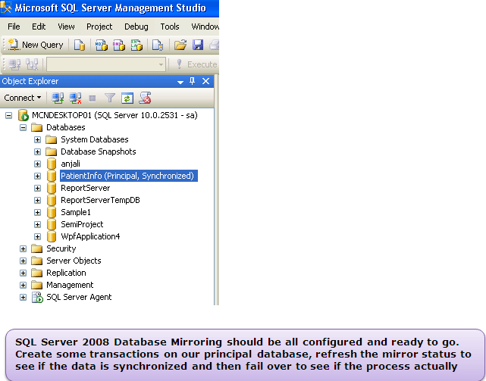

Ref:

* 1. <https://dba.stackexchange.com/questions/152484/setting-up-a-mirror-cant-find-remote-server>
  2. <https://www.c-sharpcorner.com/uploadfile/nipuntomar/sql-server-database-mirroring-part-2/>
  3. <https://www.c-sharpcorner.com/UploadFile/nipuntomar/sql-server-database-mirroring-part-3/>
  4. https://www.sqlshack.com/sql-server-replication-on-a-mirrored-database/